

Software Requirement Specification for RajMaster

[SRS]

9/6/2023

**Submitted By**

Atishay Limited

Jaipur

Table of Contents

1. Introduction: 1

1.1. Purpose 1

1.2. Scope 1

2. Technology: 2

3. Functional Requirement: 2

3.1. Urban GP: - 2

3.2. Urban Village: - 4

# Introduction:

* 1. Purpose

The purpose of this document is to present a detailed description of the “RajMasters”. It will explain the features and the interface of the system, what system will do and the constraints under which it must operate. This document will fully describe all the functional and non-functional requirements, design constrains and other factors necessary to provide a complete and comprehensive description of the requirement for the RajMasters.

Rajmaster is a centralized repository to manage, distribute and monitor of all Data Masters while at the same time synchronizing various departments/ projects for consumption of this data.

* 1. Scope

Raj masters Portal provides an integrated environment to add, update & delete respective departments master data at a single point. It is enjoyed upon all the departments to leverage Raj masters for the purpose of masters and no separate master would be created in the individual application. In case a particular master is required which is not available in SMCDH, the department concern is allowed to create in the central repository, rather than in own application

# Technology:

Portal will be built using following technologies and platforms:

|  |  |  |
| --- | --- | --- |
| **Development Phases** | | **Tools & Technology** |
| **Requirement Analysis, SRS writing** | | MS Office Word |
| **Design** | | HTML V5, CSS, JavaScript |
| **Development** | **Web Front-End Coding** | ASP.NET V4.0.3 |
| **Back-End Coding** | ASP.NET MVC5 |
| **Database** | ORACEL Server |
| **Operating System** |  |
| **Quality Assurance &** **Testing** | | Test Cases – MS Office Word 2019  Test Plans – MS Office Word 2019  Testing – Manual |

# Functional Requirement:

## Urban GP: -

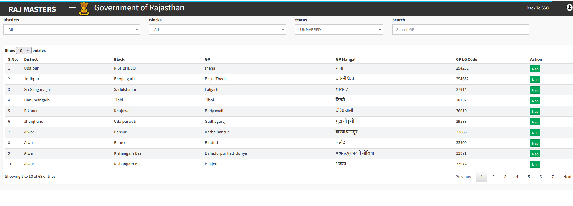

* This is the Urban GP page where user can search the Urban gram panchayat, they can view the details.
* User can use the search filter like District, Blocks, Status.
* Click on the MAP

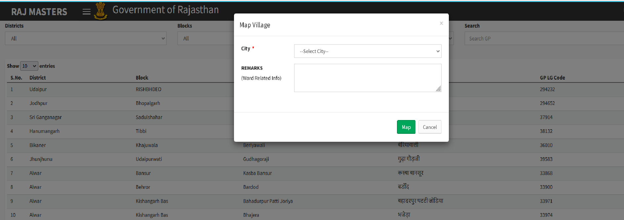

* Select the city
* Enter any remark.
* After click on Map, it will successfully be mapped with the city

## Urban Village: -

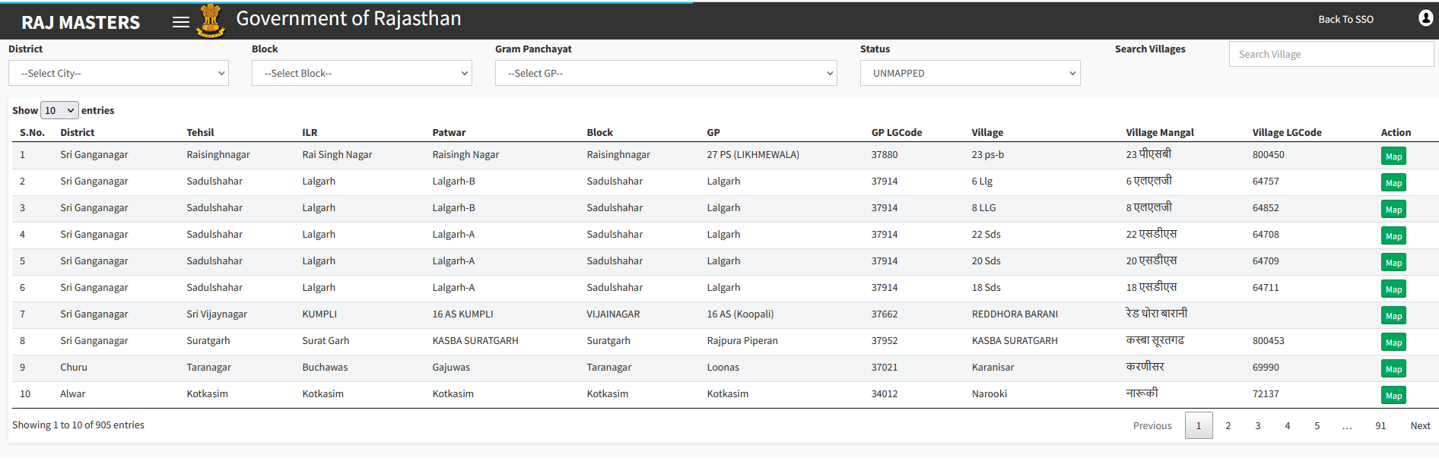

* This is the urban village page where user can view the details of the village.
* They can search the village using search filter like district, Block, Gram panchayat, Status.
* Click on the MAP



* Select the city
* Enter any remark.
* After click on Map, it will successfully be mapped with the city

**The End**